**DAILY ONLINE ACTIVITIES SUMMARY**

|  |  |  |  |  |  |  |  |  |
| --- | --- | --- | --- | --- | --- | --- | --- | --- |
| **Date:** | **30-6-2020** | | | | | **Name:** | **Prajna** | |
| **Sem & Sec** | **8th sem ‘B’** | | | | | **USN:** | **4AL16CS067** | |
| **Online Test Summary** | | | | | | | | |
| **Subject** | | **-** | | | | | | |
| **Max. Marks** | | **-** | | **Score** | | | **-** | |
| **Certification Course Summary** | | | | | | | | |
| **Course** | **Introduction to CSS** | | | | | | | |
| **Certificate Provider** | | | **Great learning** | | **Duration** | | | **5hrs** |
| **Coding Challenges** | | | | | | | | |
| **Problem Statement:**1**.** Write a c program to separate odd integers and even into separate arrays. | | | | | | | | |
| **Status: Completed** | | | | | | | | |
| **Uploaded the report in GitHub**  **GitHub link:** | | | | | **Yes**  **https://github.com/alvas-education-foundation/prajna_k** | | | |
| **If yes Repository name** | | | | | **prajna_k** | | | |
| **Uploaded the report in slack** | | | | | **yes** | | | |

Online Test Details: (Attach the snapshot and briefly write the report for the same)

Certification Course Details: (Attach the snapshot and briefly write the report for the same)

Coding Challenges Details: (Attach the snapshot and briefly write the report for the same)

2) certification course

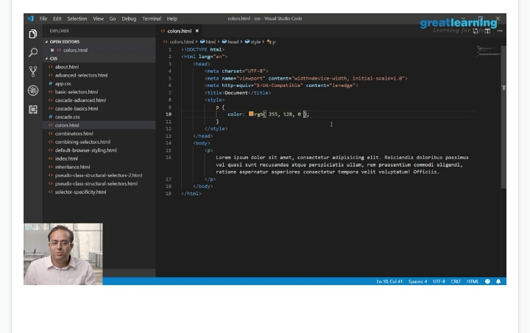

3) coding challenges

#include <stdio.h>

void main()

{

int arr1[10], arr2[10], arr3[10];

int i,j=0,k=0,n;

printf("\n\nSeparate odd and even integers in separate arrays:\n");

printf("------------------------------------------------------\n");

printf("Input the number of elements to be stored in the array :");

scanf("%d",&n);

printf("Input %d elements in the array :\n",n);

for(i=0;i<n;i++)

{

printf("element - %d : ",i);

scanf("%d",&arr1[i]);

}

for(i=0;i<n;i++)

{

if (arr1[i]%2 == 0)

{

arr2[j] = arr1[i];

j++;

}

else

{

arr3[k] = arr1[i];

k++;

}

}

printf("\nThe Even elements are : \n");

for(i=0;i<j;i++)

{

printf("%d ",arr2[i]);

}

printf("\nThe Odd elements are :\n");

for(i=0;i<k;i++)

{

printf("%d ", arr3[i]);

}

printf("\n\n");

}

|  |
| --- |
|  |
|  |  |
|  |  |
|  |  |
|  |  |
|  |  |